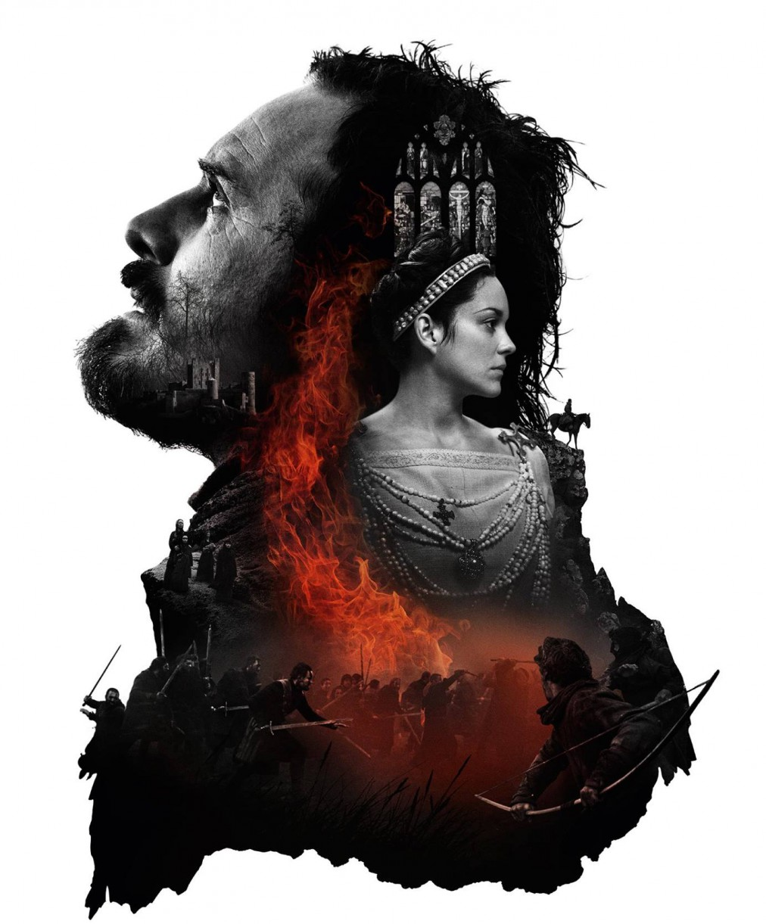

Macbeth Home Learning Booklet

Name__________________________________

Teacher_________________________________

Essay Writing Guidance

Home Learning two and four require you to write a full essay. You will have covered this in lesson. There is a useful reminder below should you need it.
Remember to track how the character or theme changes / develops throughout the play.
If you had a question on how Shakespeare presents Lady Macbeth your first paragraph would explore how she is presented at the start of the play, your second paragraph will explore how she has changed in the middle of the play and your third paragraph will explore how she is presented the end of the play.

Just ask yourself… in what way is the character presented? How do we know this? Why has Shakespeare done this?

WHAT: In what way is the character or theme presented?
HOW: how do we know this? What quotation could you use to back this up? Who says the quotation? To whom? Why?
What method is Priestley using in the quotation? Why? What is the effect?
How might a Jacobean audience react? Why?

WHY: why might Shakespeare have presented the character in this way? What might he be trying to say about society?

Home Learning One

Task

Below are your 10 key words for Macbeth. You are expected to understand each word and to use them in your writing.

Using the table below, you need to define what each word means. Try and put this into your own words to help you remember. You also need to find at least one memorable synonym for each word.

Word | Definition | Synonym
- Patriarchal

- Hamartia
- Manipulative
- Autonomy
- Volatile
- Abhorrent
- Regicide
- Naïve
- Hubris
- Relinquish

Home Learning Two

My plan
Introduction:

Paragraph One (How does Shakespeare present Lady Macbeth as a powerful woman at the start of the play?):

Paragraph Two (How does Shakespeare present Lady Macbeth as a powerful woman in the middle of the play?):

Paragraph Three (How does Shakespeare present Lady Macbeth as a powerful woman at the end of the play?)

Conclusion: (Why does Shakespeare present Lady Macbeth as a powerful woman throughout the play?)

Essay One
______________________________________________________________________________________________________________________________________________________________________________________________________________________________________________________________________________________________________________________________________________________________________________________________________________________________________________________________________________________________________________________________________________________________________________________________________________________________________________________________________________________________________________________________________________________________________________________________________________________________________________________________________________________________________________________________________________________________________________________________________________________________________________________________________________________________________________________________________________________________________________________________________________________________________________________________________________________________________________________________________________________________________________________________________________________________________________________________________________________________________________________________________________________________________________________________________________________________________________________________________________________________________________________________________________________________________________________________________________________________________________________________________________________________________________________________________________________________________________________________________________________________________________________________________________________________________________________________________________________________________________________________________________________________________________________________________________________________________________________________________________________________________________________________________________________________________________________________________________________________________________________________________________________________________________________________________________________________________________________________________________________________________________________________________________________________________________________________________________________________________________________________________________________________________________________________________________________________________________________________________________________________________________________________________________________________________________________________________________________________________________________________________________________________________________________________________________________________________________________________________________________________________________________________________________________________________________________________________________________________________________________________________________________________________________________________________________________________________________________________________________________________________________________________________________________________________________________________________________________________________________________________________________________________________________________________________________________________________________________________________________________________________________________________________________________________________________________________________________________________________________________________________________________________________________________________________________________________________________________________________________________________________________________________________________________________________________________________________________________________________________________________________________
Home Learning Three
Extension: Write a quotation to match each theme under each icon.

Themes: Shakespeare’s ‘Big Ideas’ in ‘Macbeth’
Write down the themes that are represented by these icons. You will be needing them for some of the activities in this booklet. If you think any themes are missing, add them in the spaces provided!
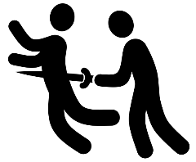
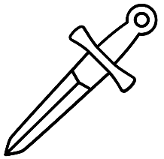

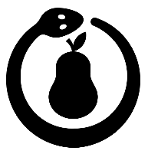
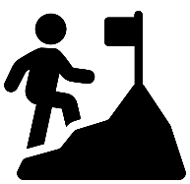

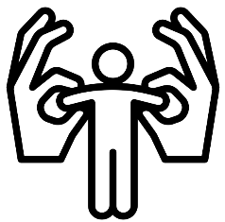

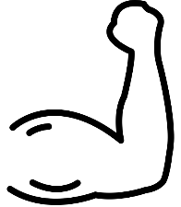
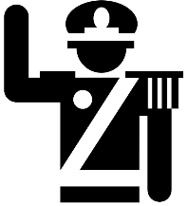
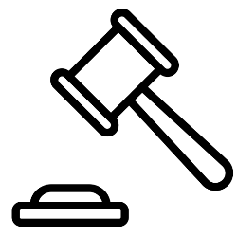

Home Learning Four

My plan
Introduction:

Paragraph One (How does Shakespeare present Macbeth as a hero at the start of the play?):

Paragraph Two (How does Shakespeare present Macbeth as a hero in the middle of the play?):

Paragraph Three (How does Shakespeare present Macbeth as a hero in at the end of the play?):

Conclusion: (Why does Shakespeare present Macbeth as a hero? Or not?)

Essay Two
______________________________________________________________________________________________________________________________________________________________________________________________________________________________________________________________________________________________________________________________________________________________________________________________________________________________________________________________________________________________________________________________________________________________________________________________________________________________________________________________________________________________________________________________________________________________________________________________________________________________________________________________________________________________________________________________________________________________________________________________________________________________________________________________________________________________________________________________________________________________________________________________________________________________________________________________________________________________________________________________________________________________________________________________________________________________________________________________________________________________________________________________________________________________________________________________________________________________________________________________________________________________________________________________________________________________________________________________________________________________________________________________________________________________________________________________________________________________________________________________________________________________________________________________________________________________________________________________________________________________________________________________________________________________________________________________________________________________________________________________________________________________________________________________________________________________________________________________________________________________________________________________________________________________________________________________________________________________________________________________________________________________________________________________________________________________________________________________________________________________________________________________________________________________________________________________________________________________________________________________________________________________________________________________________________________________________________________________________________________________________________________________________________________________________________________________________________________________________________________________________________________________________________________________________________________________________________________________________________________________________________________________________________________________________________________________________________________________________________________________________________________________________________________________________________________________________________________________________________________________________________________________________________________________________________________________________________________________________________________________________________________________________________________________________________________________________________________________________________________________________________________________________________________________________________________________________________________________________________________________________________________________________________________________________________________________________________________________________________________________________________________________________________
Home Learning Five

Witches and Witchcraft

Witches and witchcraft were viewed very differently during the reign of James I to how they are now. In short: there was a widespread belief that witches existed and that they were harmful. Unfortunate events and personal misfortune were often (wrongly) attributed to witchcraft and thousands of people were put on trial. It’s worth noting that almost all of these people were women, many of whom were old and vulnerable. Indeed, James I felt so strongly about the threat posed by witches – who he called the ‘detestable slaves of the Devil’ – that he wrote a book called Daemonologie about them. In terms of what this means for us, we need to be aware that many of the ideas and beliefs of James I are reflected in the ‘witchcraft’ scenes from the play.

Questions to Consider
- How does Shakespeare make the witches appear strange and threatening in A1-S1?
- How are the witches presented as malign and harmful at the start of A1-S3?
- Why is it important that the witches look ‘not like the inhabitants o’ the earth’ to Macbeth and Banquo in A1-S3?
- How do the reactions of Macbeth and Banquo differ when they hear the prophecies in A1-S3?
- How does Shakespeare (once again) make the witches appear strange and threatening in A4-S1?

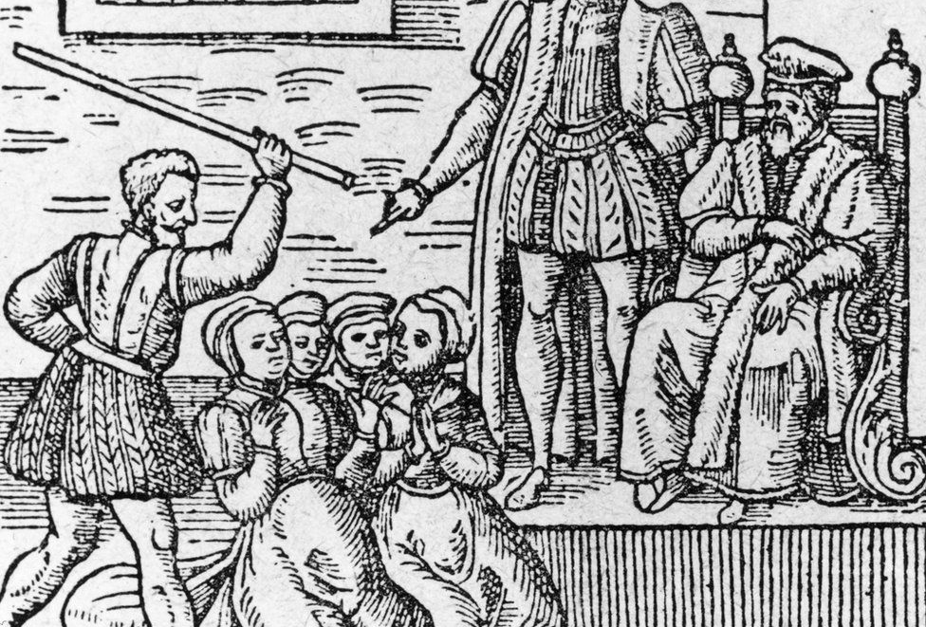

Things to Keep in Mind
- The witches seem to have a greater influence over Macbeth than Banquo
- Macbeth is strongly influenced by the correlation between the witches’ prophecies and Duncan’s decision to reward him
- The witches are presented as powerful, mysterious figures who occupy a place beyond society and the natural world
- The ‘otherness’ of the witches is signified through their grotesque appearance and distinctive patterns of speech
- There is a connection to be made between the witches and Lady Macbeth’s appeal to ‘darkness’ and evil spirts

_______________________________________________________________________________________________________________________________________________________________________________________________________________________________________________________________________________________________________________________________________________________________________________________________________________________________________________________________________________________________________________________________________________________________________________________________________________________________________________________________________________________________________________________________________________________________________________________________________________________________________________________________________________________________________________________________________________________________________________________________________________________________________________________________________________________________________________________________________________________________________________________________________________________________________________________________________________________________________________________________________________________________________________________________________________________________________________________________________________________________________________________________________________________________________________________________________________________________________________________________________________________________________________________________________________________________________________________________________________________________________________________________________________________________________________________________________________________________________________________________________________________________________________________________________________________________________________________________________________________________________________________________________________________________________________________________________

Home Learning Six

Word | Definition
- Patriarchal

- Hamartia
- Manipulative
- Autonomy
- Volatile
- Abhorrent
- Regicide
- Naïve
- Hubris
- Relinquish

Now using your knowledge of the novella, write out at least one sentence using each of the terms. Think about which character the term links to.
Extension: can you add in a comment on authorial intent? Why might Dickens have decided to portray the character in this way?

____________________________________________________________________________________________________________________________________________________________________________________________________________________________________________________________________________________________________________________________________________________________________________________________________________________________________________________________________________________________________________________________________________________________________________________________________________________________________________________________________________________________________________________________________________________________________________________________________________________________________________________________________________________________________________________________________________________________________________________________________________________________________________________________________________________________________________________________________________________________________________________________________________________________________________________________________________________________________________________________________________________________________________________________________________________________________________________________________________________________________________________________________________________________________________________________________________________________________________________________________________________________________________________________________________________________________
________________________________________________________________________________________________________________________________________________________________________________________________________________________________________________________________________________________________________________________________________________________________________________________________________________________________________________________________________________________________________________________________________________________________________________________________________________________________________________________________________________________________________________________________________________________________________________________________________________________________________________
____________________________________________________________________________________________________________________________________________________________________________________________________________________________________________________________________________________________________________________________________________________

