Busy, busy, busy in the Library!
Scholastic Book Fair: During the week beginning 22nd November 2021 we ran the Scholastic Book Fair, and thanks to parents, guardians and students, over £800 was spent which meant we earnt £400 worth of books for our library! Due to this success we have booked to run the fair again this November!
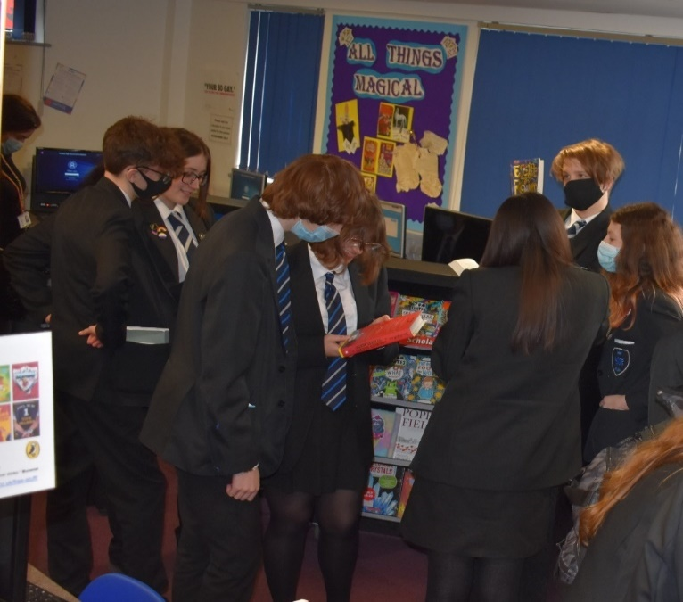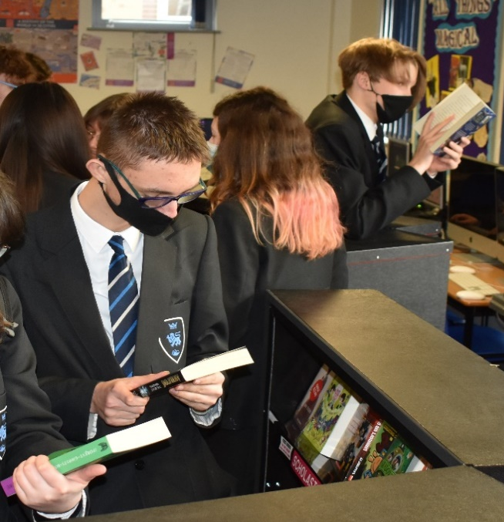

BookTrust BookBuzz: In December we had our delivery of BookBuzz books! Every Year 7 student was given the opportunity to choose and take home a book from a list created by a panel of experts to ensure quality, suitability and to encourage reading for pleasure:
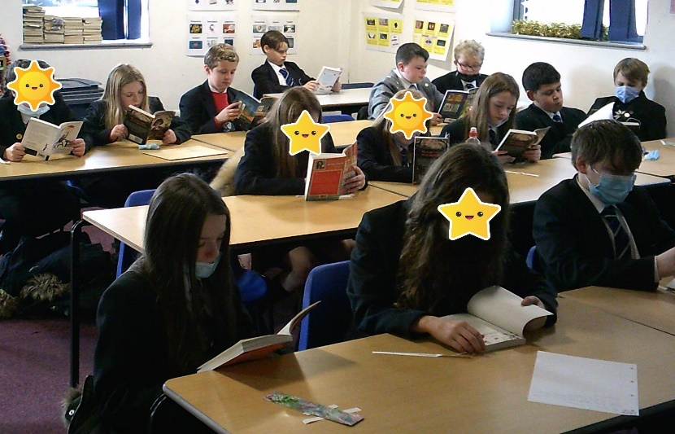

The Siobhan Dowd Trust: The Trust works to give young people the opportunity to read and enjoy literature. This year the Trust funded 6 secondary and 14 primary schools so that they could choose their own selection of books for advent activities. They had over 400 applications and we were one of the six secondary schools in the country to receive £300 to spend at our local bookstore Linghams. Eight lucky students chose a wide and varied selection of books for our school community to enjoy. The books were revealed in an advent activity in the run up to Christmas:
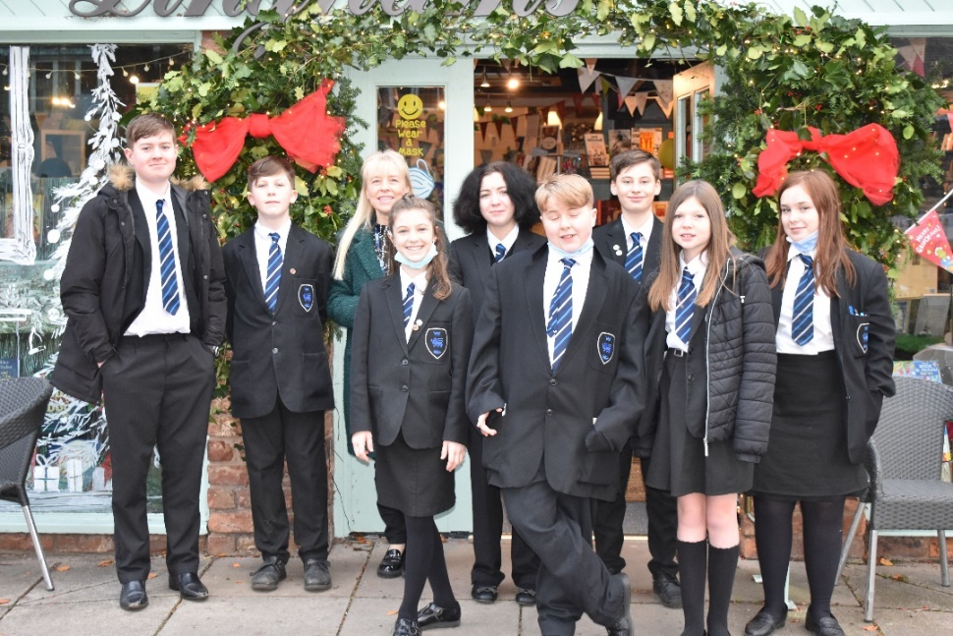
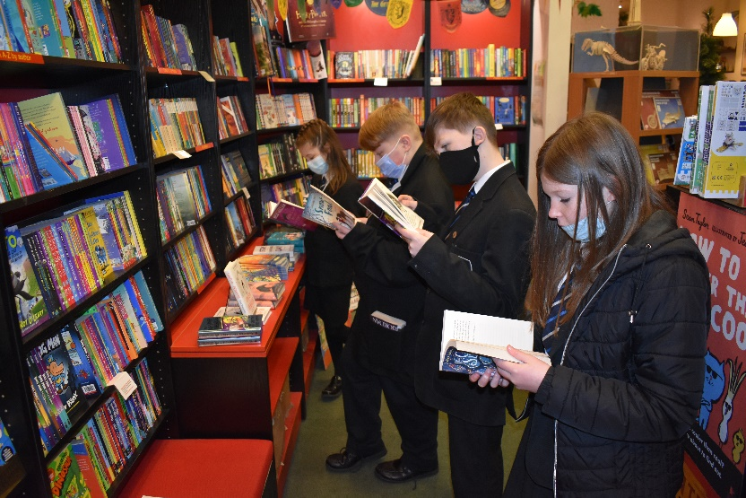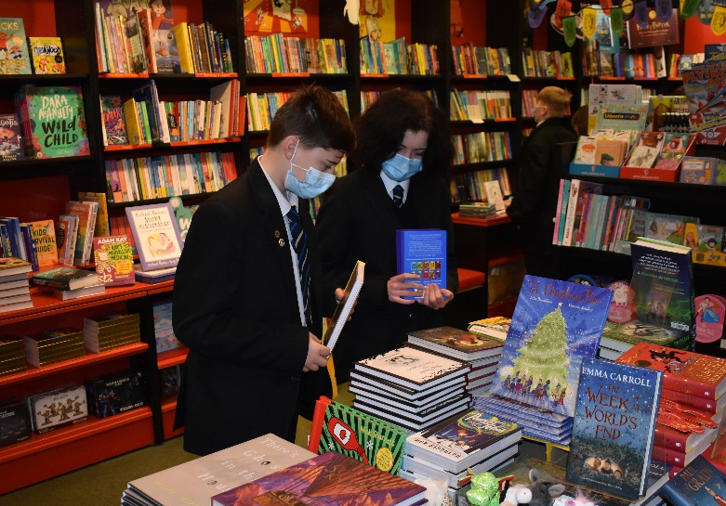
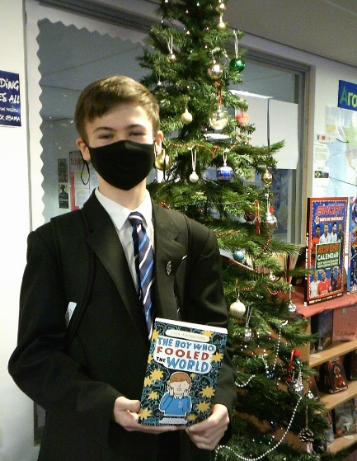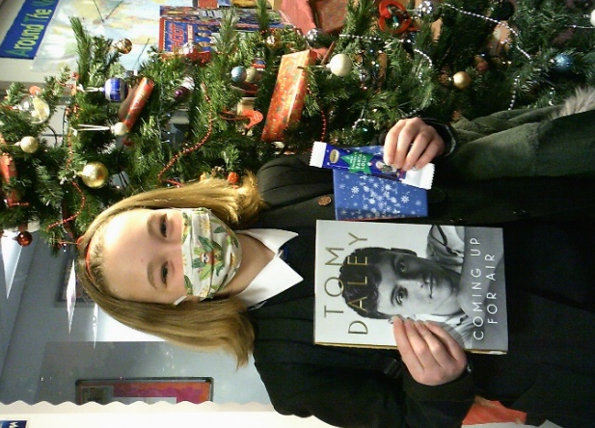

Authors visits:
In January Year 8 had a virtual visit with Jamie Russell, author of the Sci-Fi adventure trilogy Skywake. Jamie did a very good job of convincing not just the students but also the teachers, that gaming is good for you and can help you read more books!

In February Year 9 had a virtual visit with Darren Shan, famous for his young adult horror and fantasy books! The genre Horror has its own section in our library as it is so popular with our students.
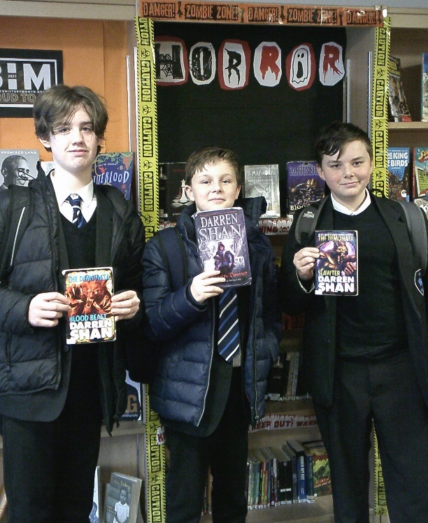

Harry Potter Day: On February 3rd we celebrated Harry Potter Book Night. This year it is an extra special event as it the 25th anniversary of the first book, ‘Harry Potter and the Philosopher’s Stone’. We had many magical activities throughout the day for our witches, wizards and muggles. Thank you to all who gave a donation in return for their child’s photograph – we raised enough to purchase the hardback, illustrated copies of the first four books:
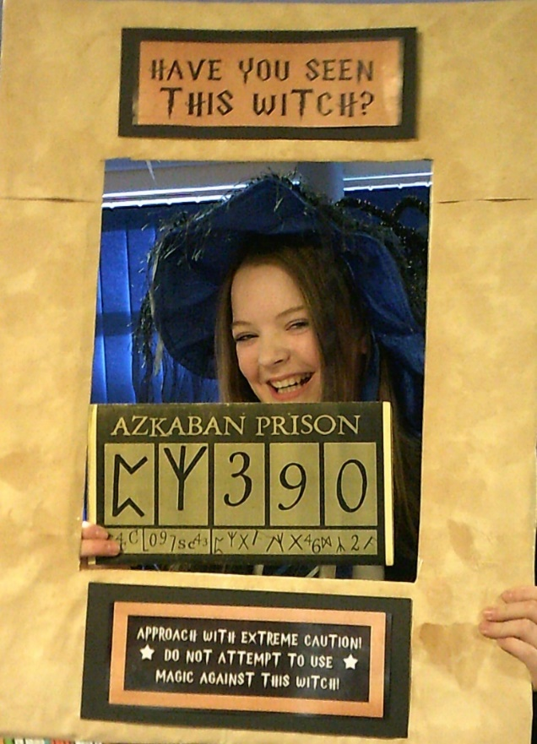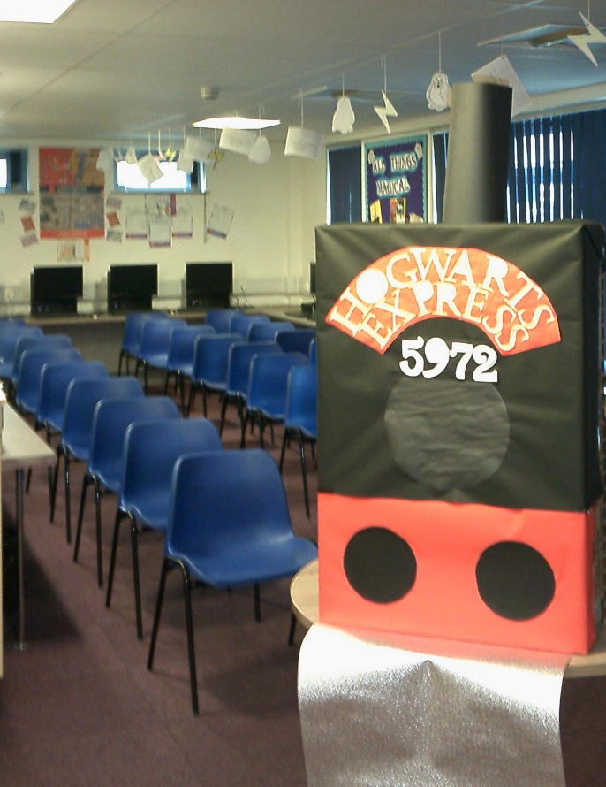

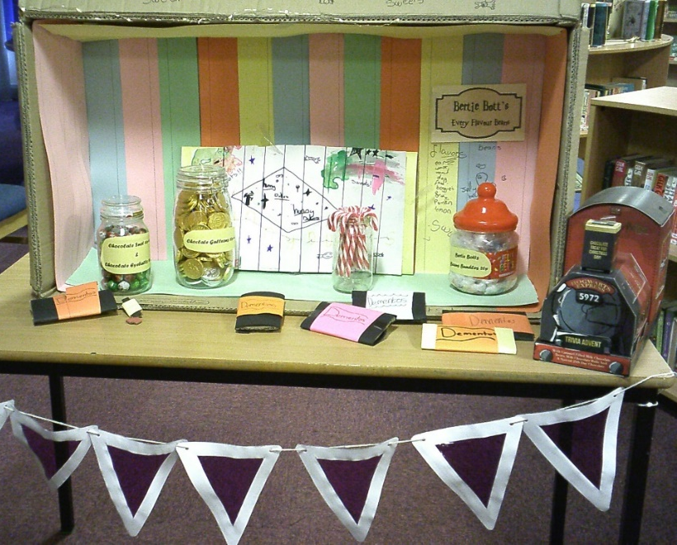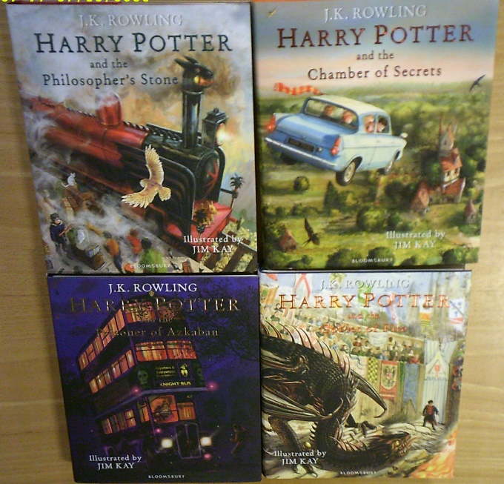

World Book Day: In March we celebrated 25 years of World Book Day. Students had elements of books and reading in all their lessons throughout the day. For example, we had a local illustrator in working with art, in food technology we used recipe books to design appropriate menus for famous literary characters, in ICT students made Kahoot quizzes and tested each other on books they are reading and in geography students looked at an extract from Captain Scott’s Journey to the South Pole. Many staff amused the students by dressing up as characters from famous books and comics:
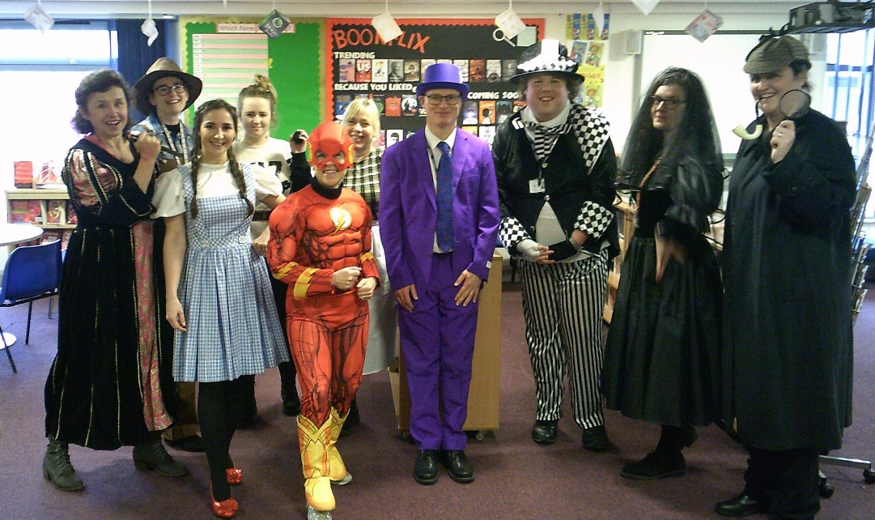
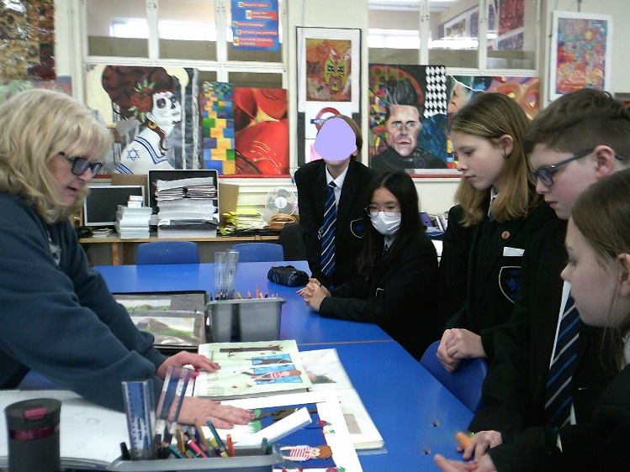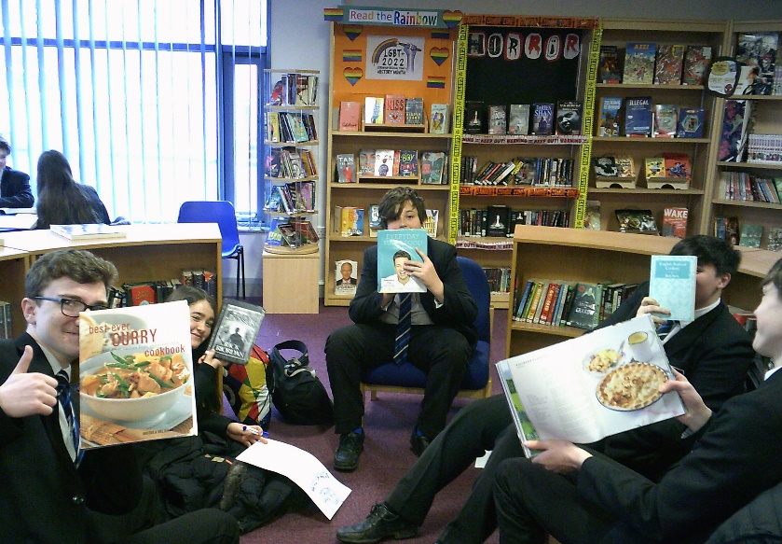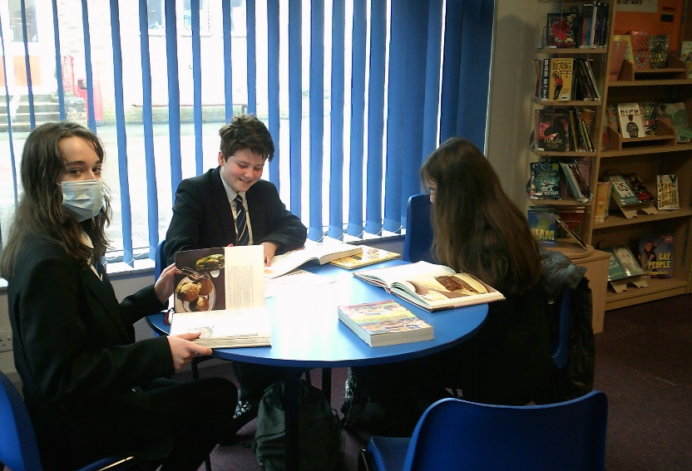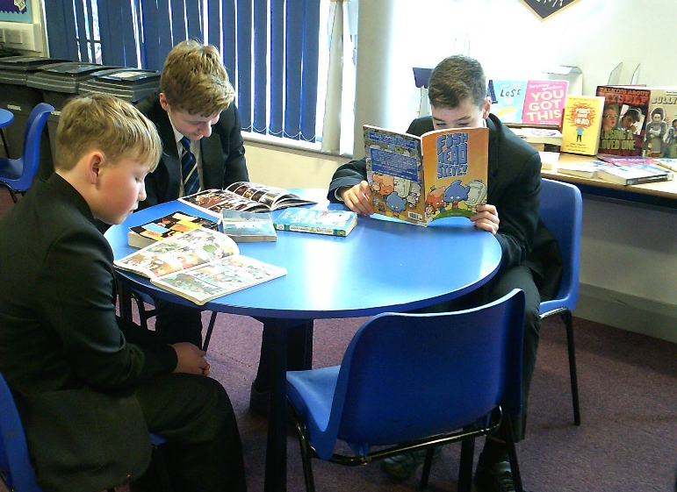

Competitions: We run many competitions throughout the year giving all students a chance to win prizes including books.
Valentine Poem/Comic strip winner:
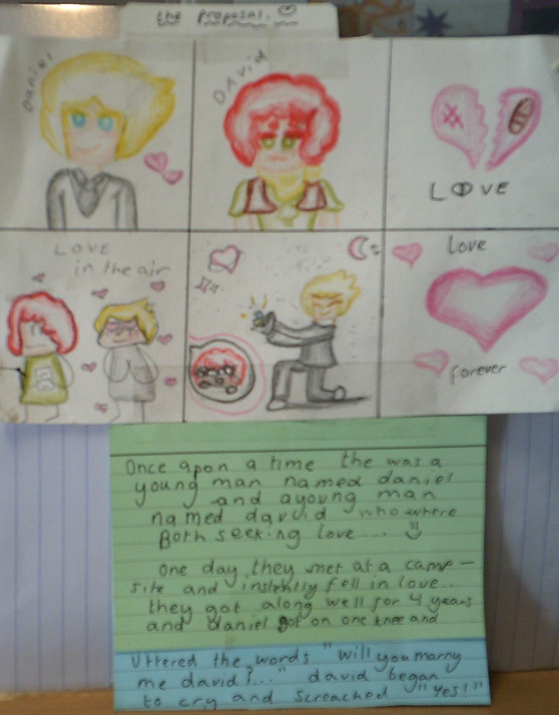

Harry Potter Letter writing winners:
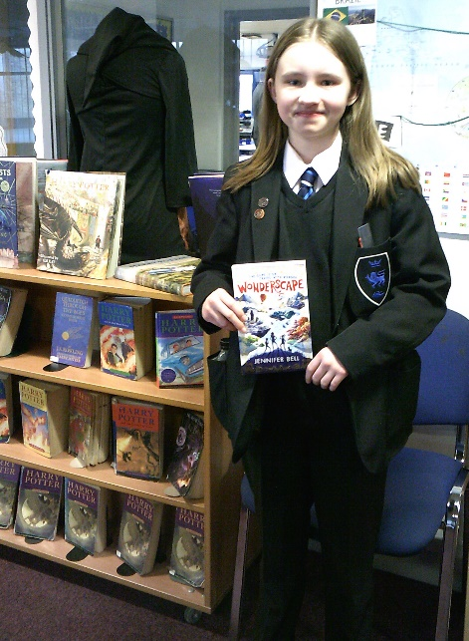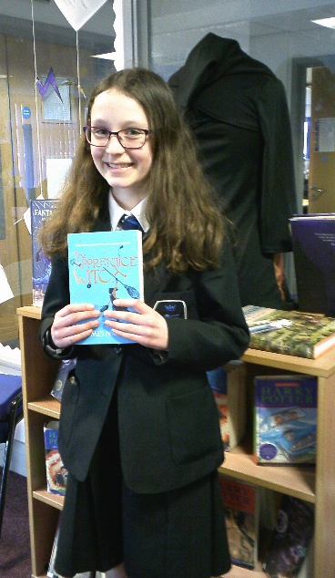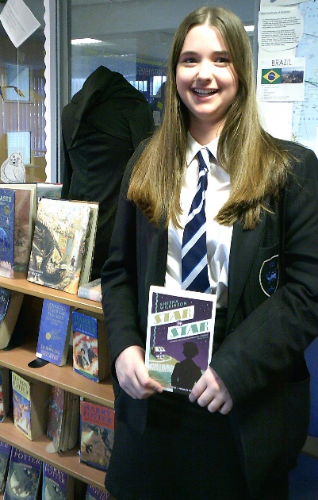

Aiding Reading: There are some simple tips to help your child with reading for pleasure:
The right environment
The best place to read is somewhere quiet with few distractions, and this is usually in bed. Does your child have a bedside lamp or a reading light because you want them to snuggle down, relax, read and then fall to sleep – having to get up to turn a main light off will spoil the effect.

Distractions
Noise, games, phones, television, music, people – these are all distractions. Remove these distractions as much as possible at reading time.

Making time
In library lessons we keep track of students reading and when they don’t seem to be doing much we discuss the reasons. Students can be busy with after school clubs, homework and home life in general. We ask all students to try and stop what they’re doing and go to bed 5 or 10 minutes earlier, pick up their book and read a target amount such as 10 pages or a short chapter or for 15 minutes – every little helps.

The right level and interest
We do our best to recommend suitable books based on a student’s interests and reading level. Book choice shouldn’t be forced but they should be encouraged to read a wide variety, including non-fiction and graphic novels. At school we encourage students to visit the library often to change books, we have interesting displays, and we run competitions. Where possible we encourage you to make books and other reading material available at home, whether you buy new or used or indeed make use of all the free facilities at your local library.

